**How to Install a CentOS 7.3 Minimal Server**

In this tutorial, I will show you how to install CentOS 7 on WMware

1. Create New Virtual Machine

Select **File** -> **New Virtual Machine…**

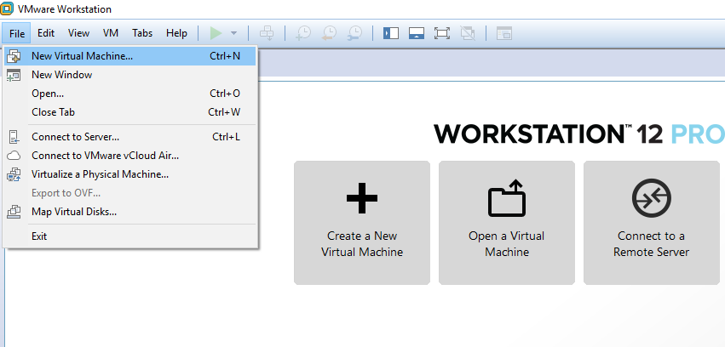

1. Select **Typical (Recommended)** and click **Next**

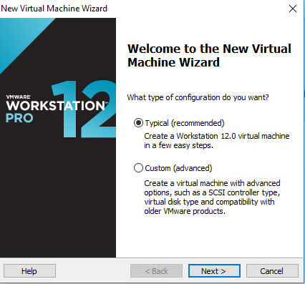

1. Select **I will install the operating system later** and click **Next**

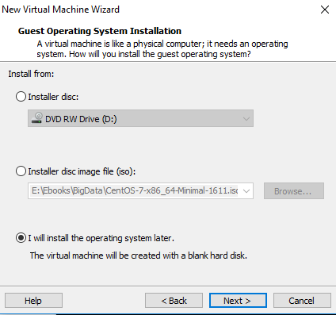

1. Select Guest operating system **Linux** and version **CentOS 64-bit**

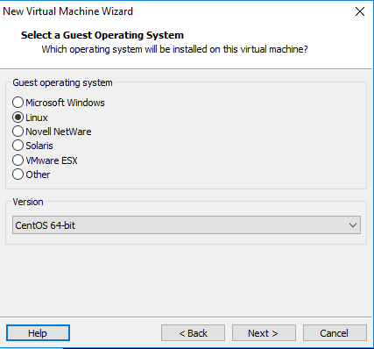

1. Enter Virtual machine name and Location to store VM then click **Next**

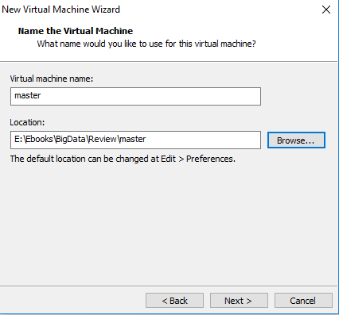

1. Enter **Maximum Disk Size.** Here I set 60G. And select **Split virtual disk into multiple files**

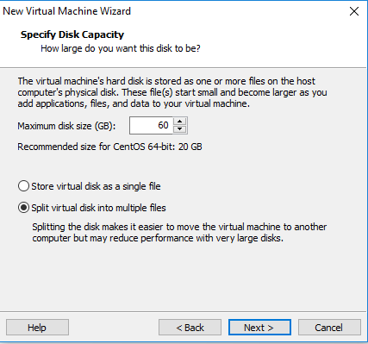

1. Click **Customize Hardware…**

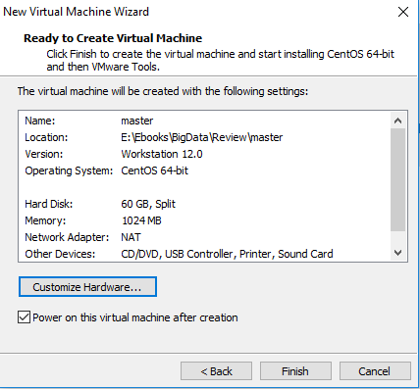

1. Set **Memory for this virtual machine** (Here I set 2048, it means 2GB Ram) and select **NAT** for **Network Adapter.** Click **New CD/DVD** and browse to installer .iso file. Then click **Close.**

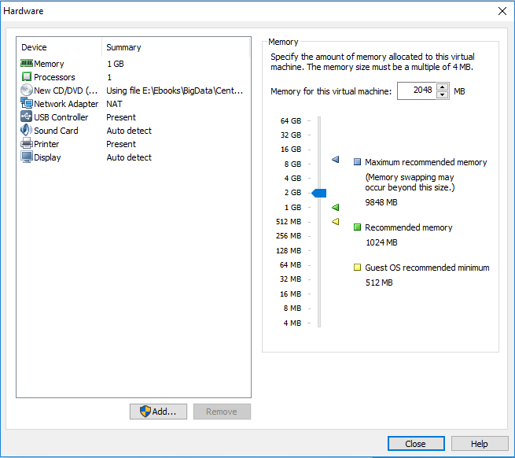

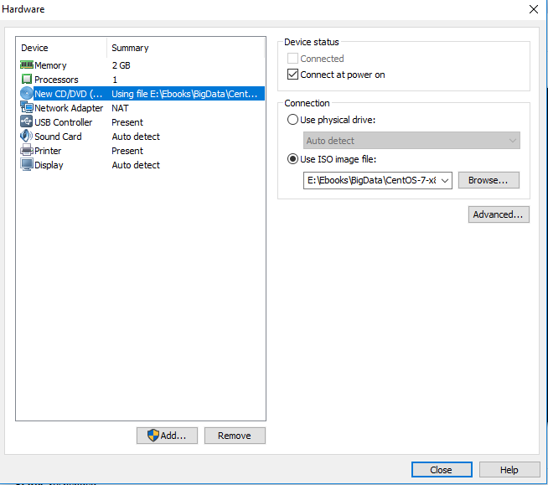

1. Click **Finish**

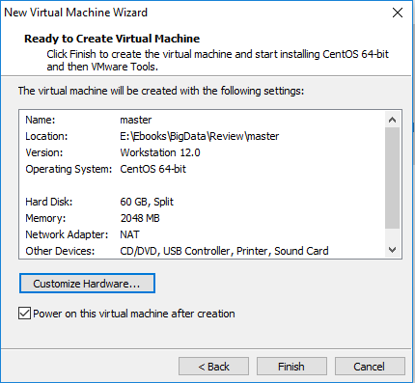

1. Click **Power on this virtual machine**

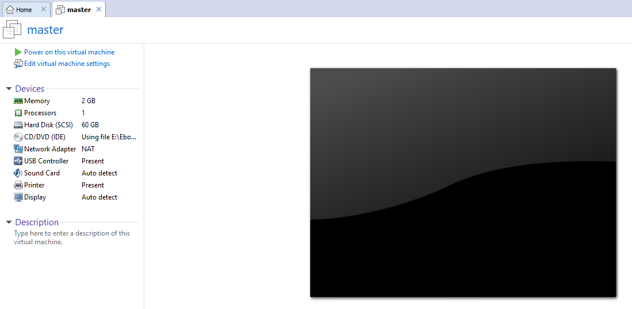

1. Now we start to install CentOS 7. Press up arrow key to select **Install CentOS Linux 7**

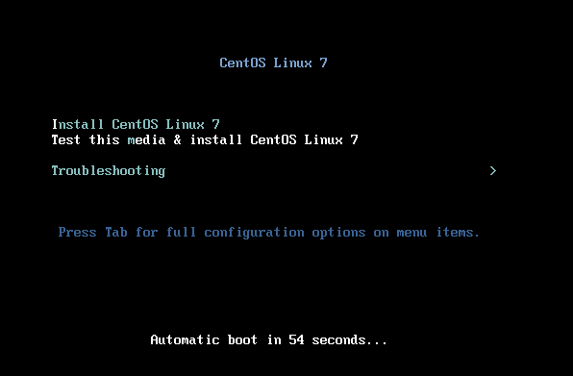

1. Select language **English** and click **Continue**

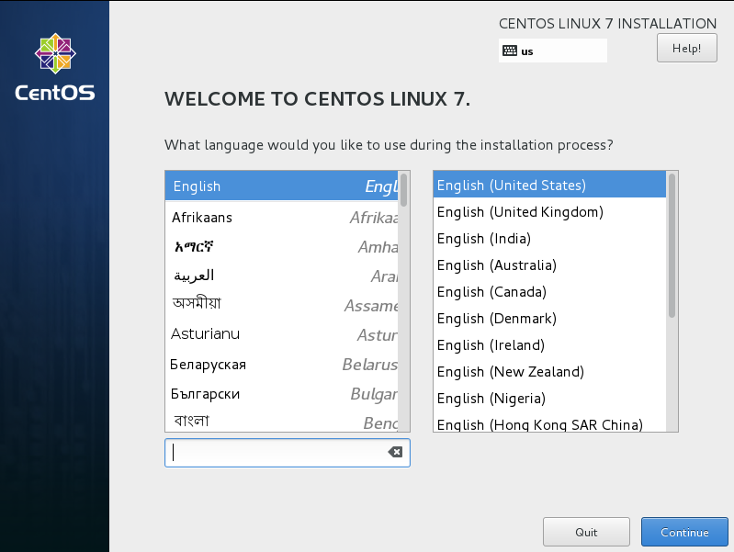

1. At the following screen, select **DATE & TIME**

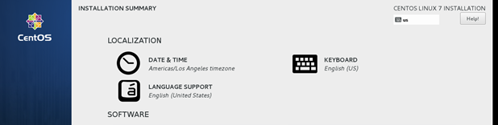

1. Select **Region, City, Time, Date**. Click **Done.**

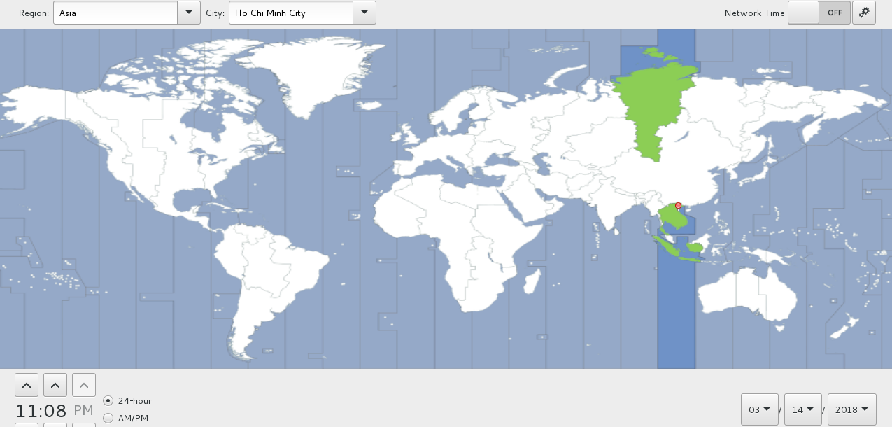

1. Set **NETWORK & HOSTNAME**

Here I enter **bigdata.vn** for **Host name**

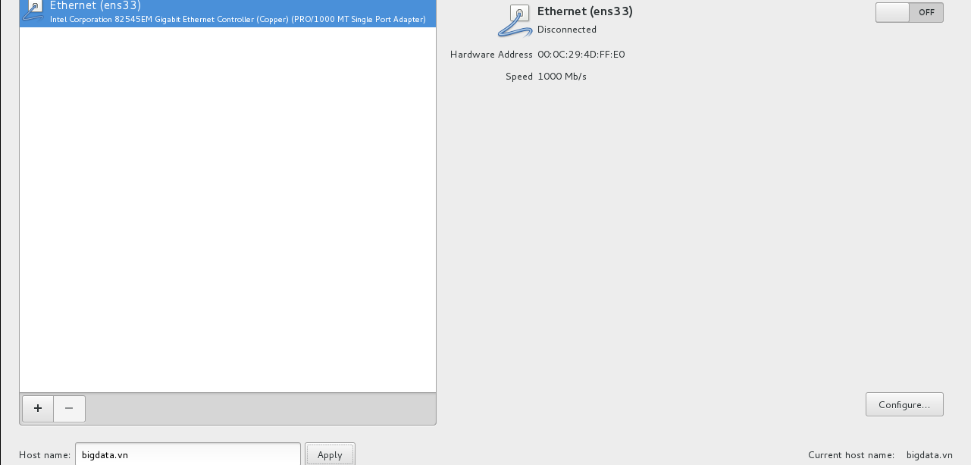

Click on **Configure** to setup Network. First, we need to know IP of **NAT VMWare**, in real computer, open Command Prompt and enter **ipconfig /all**

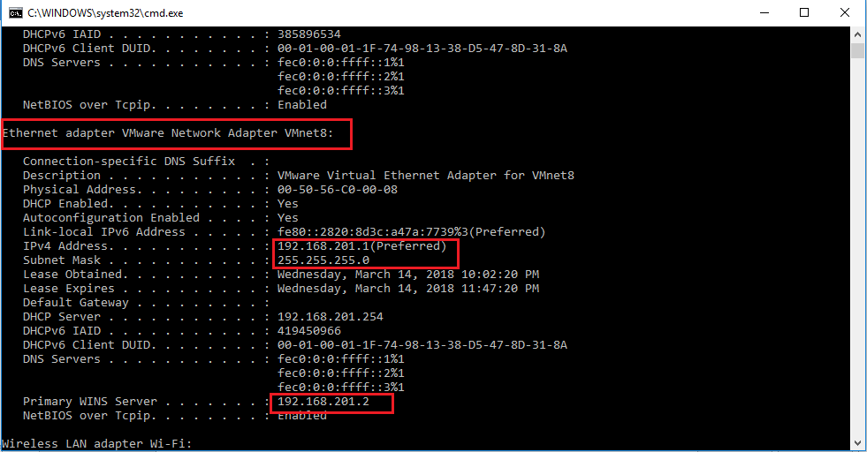

Here the network IP is 192.168.201.0/24 and Gateway 192.168.201.2, so I set my VM IP **192.168.201.50**

At the following screen, select **IPv4 Settings** and method **Manual**

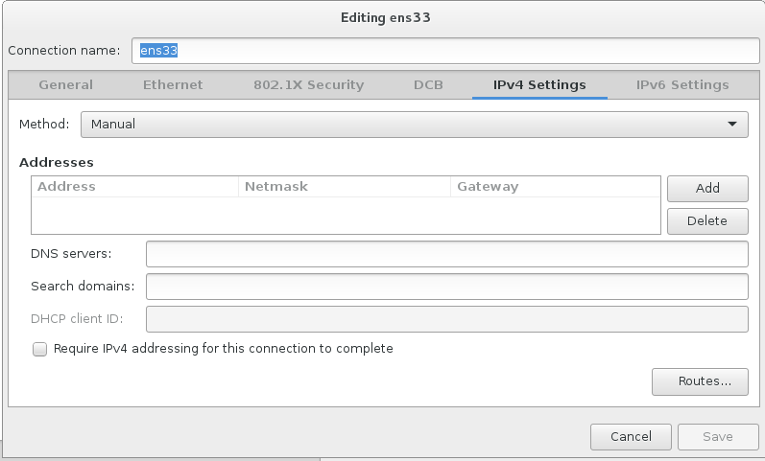

1. Click **Add.** Enter Address, Netmask, Gateway and DNS servers. Then click **Save**

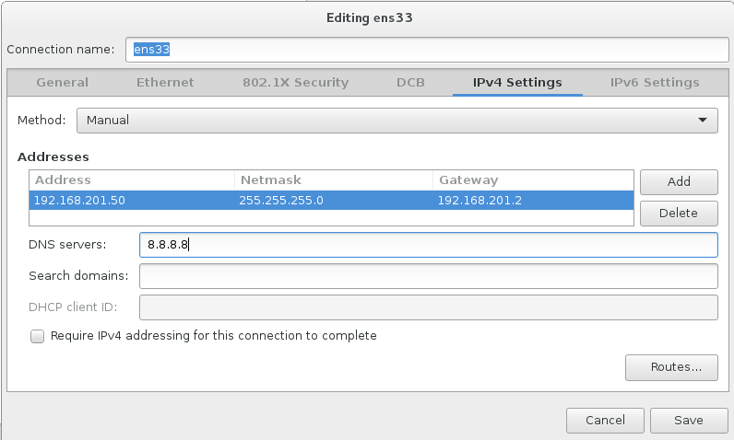

1. Turn network card **ON** and click **Done**

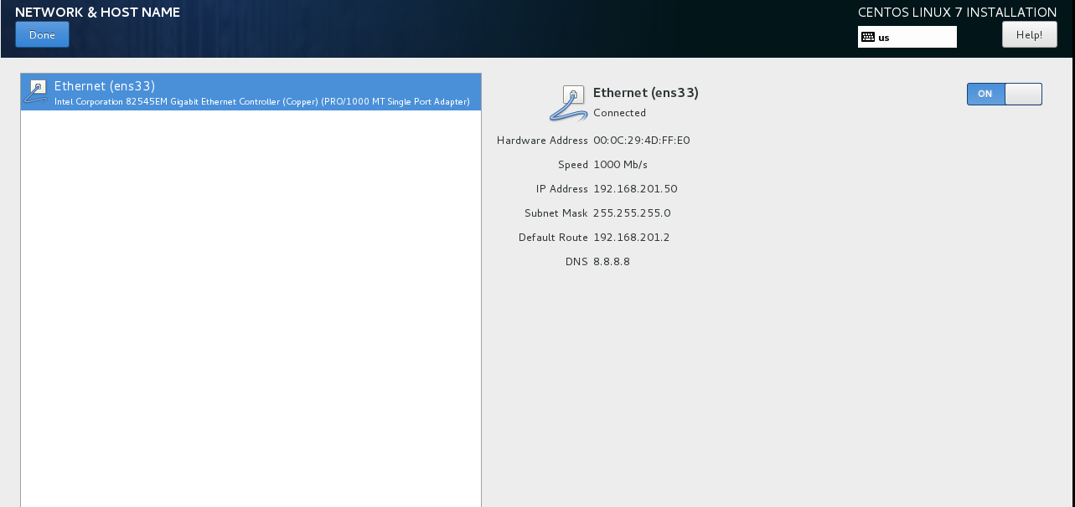

1. Click **INSTALLATION DESTINATION** and select **DONE**

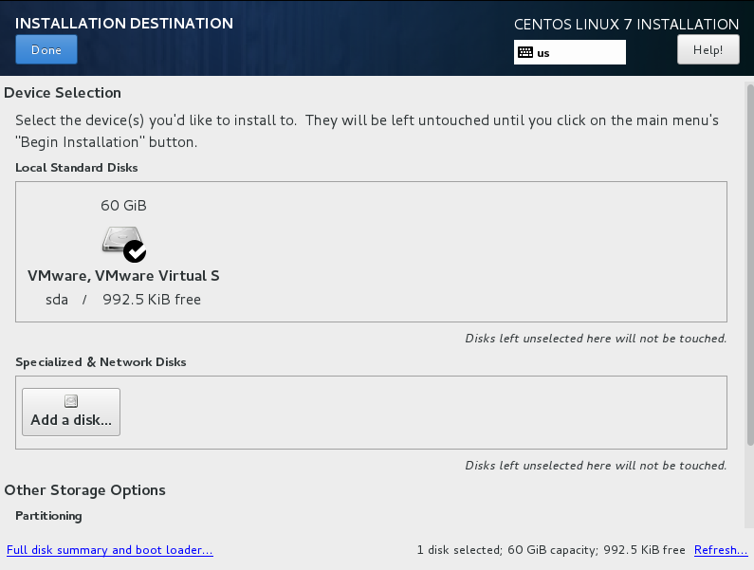

1. Click **Begin Installation**
2. Set **Root Password** and click **Done** twice.

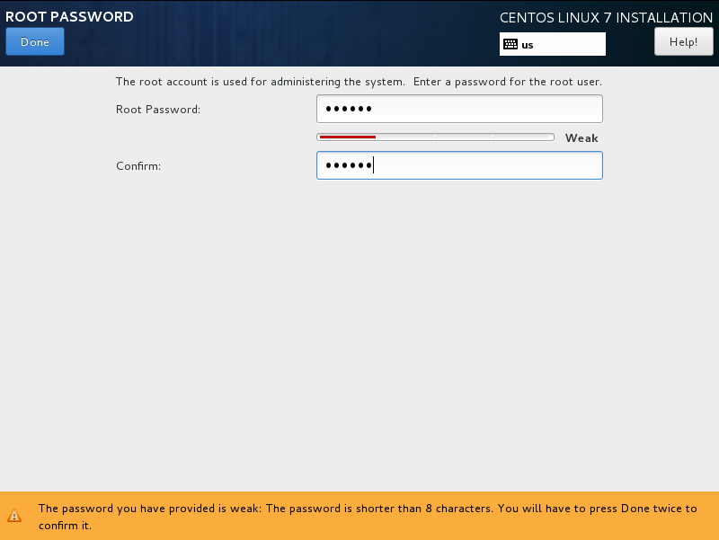

1. Wait for the installation process to complete

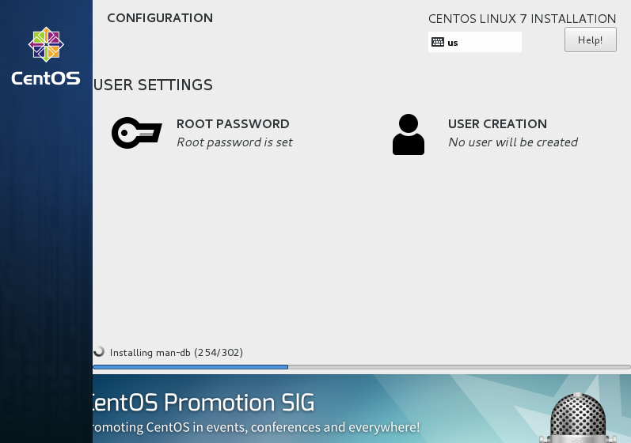

1. Click **Reboot**

u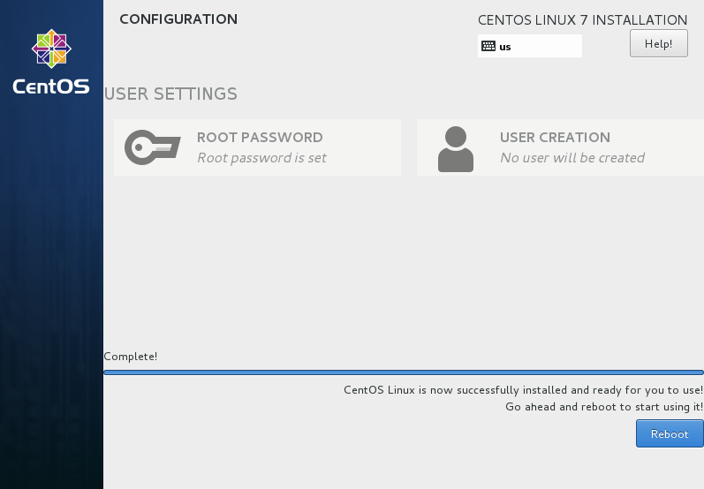

1. Update system and install necessary tools: Enter the following command with root privilege

**yum update**

**yum install net-tools**

**yum install nano**

**yum install ntp**

1. Enter the following command to update time

**ntpdate time.apple.com**